

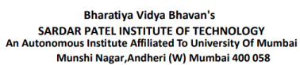

**CONSUMER ELECTRONICS**

**EXPERIMENT 3 : Report on IDEA Lab**

**UID :** 2021300101

**Batch :** C

**Submitted By:**

Adwait Purao

**Submitted To:**

Prof. Milind Paraye

**Contents**

1. Introduction to IDEA Lab ...................................................................................................................... 2 2. Laboratories in IDEA Lab ...................................................................................................................... 2 3. Equipments studied ................................................................................................................................ 3

a. CO2 Laser Cutter & Engraver ................................................................................................ 3 b. Vinyl Cutter & Printer................................................................................................................ 4 c. 3D Printer....................................................................................................................................... 5 d. Digital IC Tester........................................................................................................................... 6 e. Desktop CNC Milling.................................................................................................................. 7

4. Advantages of IDEA Lab ......................................................................................................................... 8 5. Future Development ............................................................................................................................... 8 6. Idea for Product Development ............................................................................................................ 8 7. Conclusion ................................................................................................................................................... 9

1

**Introduction to IDEA Lab**

The AICTE-established IDEA Lab in our college enhances STEM education by offering a space for students to apply theoretical concepts through hands-on learning. It fosters creativity and innovation, preparing engineering graduates to tackle real-world challenges.

This dynamic lab encourages collaboration between students and faculty, promoting a culture of innovation. It plays a crucial role in shaping students into skilled engineers and imaginative problem-solvers, reflecting the college's commitment to holistic education.

**Key Points:**

● The IDEA Lab in our college promotes the practical application of STEM fundamentals through immersive, hands-on experiences.

● Students are encouraged to engage in "learning by doing," allowing them to visualize and realize their product ideas within the lab.

● The lab is designed to make our engineering graduates not only knowledgeable but also highly creative and imaginative.

● It provides comprehensive training in critical 21st-century skills, including problem-solving, design thinking, collaboration, and communication.

● The establishment of the IDEA Lab is in alignment with the National Educational Policy 2020 and the Prime Minister's vision for a modern, skill-oriented education system.

**Laboratories in IDEA Lab**

● **Electronics Lab**: This lab is equipped with the latest tools and equipment for designing, testing, and prototyping electronic circuits and systems. It provides students with hands-on experience in working with microcontrollers, sensors, and other electronic components, supporting projects related to embedded systems, IoT, and automation.

● **Mechanical Lab**: The mechanical lab is designed for prototyping and testing mechanical components and systems. It includes tools for machining, 3D printing, and computer-aided design (CAD) software. Students can work on projects involving robotics, material testing, and product design, gaining practical skills in mechanical engineering.

● **Photo Studio**: The photo studio offers a professional environment for photography and videography. It is equipped with high-quality cameras, lighting setups, and backdrops, allowing students to create visual content for their projects. This lab is ideal for media-related projects, including documentation, marketing materials, and creative photography.

2

**Equipments Studied**

**1. CO2 Laser Cutter and Engraver**

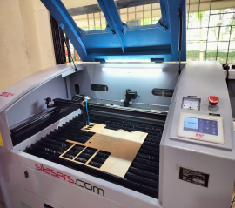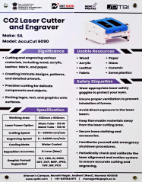

**Device Description:**

A CO2 laser cutter and engraver is a type of industrial machine tool that uses a high-powered carbon dioxide laser to cut, engrave, or mark materials like wood, acrylic, paper, and some metals. The laser beam is precisely controlled by computer to follow a design and cut or etch the material.

**Uses:**

● Cutting and shaping of materials like wood, plastic, acrylic, and thin metals ● Engraving and etching designs into the surface of materials

● Marking and labeling of products and materials

● Prototyping and fabricating small parts and products

**Advantages:**

● Highly precise and consistent cutting/engraving without physical contact ● Can cut intricate designs and shapes with great accuracy

● Fast processing speeds compared to manual cutting/engraving

● Can handle a variety of materials, making it a versatile tool

● Computer control allows for easy programmatic operation

3

**2. Vinyl Cutter & Printer**

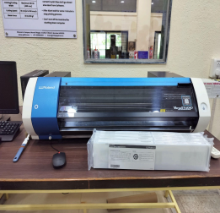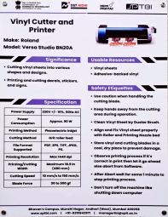

**Device Description:**

A vinyl cutter, also known as a plotter, is a computer-controlled machine that uses a small blade to cut shapes and designs out of thin sheets of vinyl or other flexible materials. Vinyl printers are similar devices that print directly onto vinyl sheets.

**Uses:**

● Cutting vinyl graphics, decals, signs, and stickers

● Producing custom labels, vehicle graphics, window displays, and more ● Printing directly onto adhesive-backed vinyl for high-quality output ● Creating custom apparel designs, logos, and iron-on transfers

**Advantages:**

● Versatile for a wide range of cutting and printing applications

● Precise control over shapes, sizes, and placement of designs

● Cost-effective way to produce custom graphics and signage

● Can handle large format materials up to several feet wide

● Fast production compared to hand-cutting or screen printing

4

**3. 3D Printer**

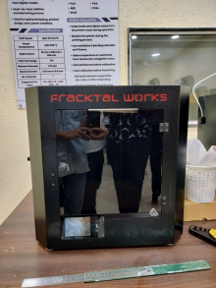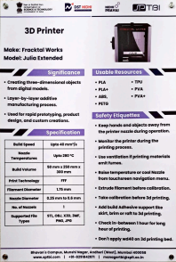

**Device Description:**

A 3D printer is a machine that creates three-dimensional objects by building them up in layers. It takes a digital 3D model and translates that into physical form by extruding or depositing material, typically plastic or resin, to create the object.

**Uses:**

● Rapid prototyping of product designs and concepts

● Manufacturing customized parts, components, and products

● Creating complex geometries and shapes not feasible with traditional methods

● Producing specialized items, tools, and small-batch products on-demand ● Educational and hobbyist applications for 3D modeling and making

**Advantages:**

● Ability to create complex 3D shapes and geometries

● Rapid iteration and design changes during the prototyping process ● Cost-effective for producing small batches or customized items

● Wide range of printable materials including plastics, resins, metals ● Compact desktop design suitable for offices, workshops, and schools

5

**4. Digital IC Tester Device Description:**

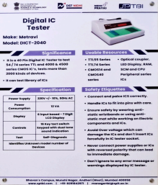

A digital IC (Integrated Circuit) tester is an electronic testing device used to evaluate the functionality and performance of digital integrated circuits, such as microprocessors, memory chips, and logic gates. It can automatically detect faults, measure parameters, and identify issues with the IC.

**Uses:**

● Testing and troubleshooting of digital ICs during manufacturing, repair, or research

● Verifying the proper operation of ICs in electronic circuits and systems ● Identifying faulty or defective ICs for replacement or repair

● Performing compliance and conformance testing on digital ICs ● Characterizing the performance and specifications of ICs

**Advantages:**

● Automated testing capabilities to quickly evaluate IC functionality ● Ability to perform a wide range of tests, including logic, timing, and parametric

● Provides detailed diagnostic information to pinpoint issues with the IC ● Can handle a variety of IC packages and technologies

● Useful for quality control, failure analysis, and R&D applications 6

**5. Desktop CNC Milling:**

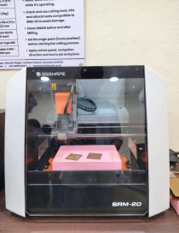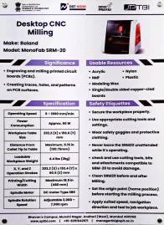

**Device Description:**

A desktop CNC (Computer Numerical Control) milling machine is a compact, precision-controlled machining tool that can shape, carve, and mill a variety of materials like wood, plastic, aluminum, and other soft metals. It uses computer-controlled servo motors to move a cutting tool along X, Y, and Z axes to create 3D shapes.

**Uses:**

● Prototyping and fabricating small-scale mechanical parts and products ● Sculpting and carving detailed designs and models out of solid materials ● Milling customized components for machines, electronics, and other applications

● Manufacturing small batches of specialized items with precision

**Advantages:**

● Highly precise and repeatable cutting and milling operations

● Ability to create complex 3D shapes and geometries

● Automated, hands-off operation once programmed

● Relatively low cost compared to industrial CNC machines

● Compact desktop design suitable for small workshops and makerspaces 7

**Advantages of IDEA Lab**

1. **Hands-On Learning**: The lab provides practical experience with STEM concepts, bridging the gap between theory and application.

2. **Fostering Innovation**: It encourages creativity and problem-solving skills, allowing students to experiment and develop novel solutions.

3. **Interdisciplinary Collaboration**: The lab promotes teamwork across different engineering disciplines, enhancing collaborative skills and knowledge sharing. 4. **Real-World Preparation**: By working on real-world projects, students are better prepared for industry challenges and job requirements.

5. **Skill Development**: Students gain technical skills in areas such as electronics, mechanical systems, and media production, making them more versatile professionals.

**Future Development**

1. **Expansion of Facilities**: Introducing advanced tools and technologies to keep pace with emerging trends and industry needs.

2. **Enhanced Industry Partnerships**: Collaborating with companies for internships, workshops, and project sponsorships to provide practical exposure and networking opportunities.

3. **Curriculum Integration**: Incorporating lab projects into the academic curriculum to ensure that hands-on learning is an integral part of the educational experience. 4. **Innovation Competitions**: Organizing hackathons, design challenges, and innovation contests to stimulate creative thinking and showcase student projects. 5. **Sustainability Initiatives**: Developing eco-friendly practices and sustainable technologies within the lab to address environmental concerns and promote green engineering.

**Idea for Product Development**

**Smart Campus Solutions**: Develop a comprehensive system to enhance campus management and student experience. This could include smart sensors for energy management, automated attendance systems using facial recognition, and a mobile app for real-time campus information and notifications. This product would leverage IoT, data analytics, and AI to create a more efficient, connected, and user-friendly campus environment.

8

**Conclusion**

The IDEA Lab represents a significant advancement in our college’s approach to STEM education by providing a space for practical, hands-on learning and innovation. Its advantages include fostering creativity, enhancing real-world skills, and promoting interdisciplinary collaboration. Looking ahead, the lab’s development will focus on expanding facilities, strengthening industry connections, and integrating innovative solutions into the curriculum. The proposed Smart Campus Solutions project exemplifies the lab’s potential to drive impactful, real-world applications. Ultimately, the IDEA Lab embodies the college’s commitment to preparing students for success in the rapidly evolving technological landscape.

9